Accelerated Reader at Home.
As part of their English curriculum, year seven learners use the Accelerated Reader program. This allows them to develop essential literacy skills, build a wider vocabulary and expose themselves to a wide range of reading material.
As we face the likelihood of school closures, we want to ensure minimal impact on learning and progress, and therefore would like to encourage the use of Accelerated Reader at home. A valuable resource for learning, it may also prove to be a source of entertainment or distraction for students during a confusing or anxious time.

There are targets set by class teachers, including word count challenges, vocabulary builders and other literacy based achievement points.

Students have visited the school library, and have a new library book to read in the event of closure. Below, you will find guidance on how to access the Academy’s Accelerated Reader platform.

What is Accelerated Reader?

Accelerated Reader is a computer program that helps teachers manage and monitor children’s independent reading practice. Your child picks a book at his own level and reads it at his own pace. When finished, your child takes a short quiz on the computer. (Passing the quiz is an indication that your child understood what was read.) Accelerated Reader gives children and teachers feedback based on the quiz results, which the teacher then uses to help your child set goals and direct ongoing reading practice.
Children using Accelerated Reader choose their own books to read, rather than having one assigned to them. This makes reading a much more enjoyable experience as they can choose books that are interesting to them.
Teachers and librarians help your child choose books at an appropriate readability level that are challenging without being frustrating, ensuring that your child can pass the quiz and experience success.
If your child does not do well on the quiz, the teacher may help your child:

Choose another book that is more appropriate.
Ask more probing questions as your child reads and before your child takes a quiz.
Pair your child with another student, or even have the book read to your child.
In most cases, children really enjoy taking the quizzes. Since they’re reading books at their reading and interest levels, they are likely to be successful. This is satisfying for most children. Best of all, they learn and grow at their own pace.

How can I help my child become a better reader?
As with anything, performance improves with practice. Encourage your child to read at home. Create a culture of reading in your household by reading with your child, starting a home library, visiting your local library or bookstore on a regular basis, letting your child see you reading, and discussing books that each of you has read. When reading with your child, stop and ask questions to be sure your child is comprehending what is read. Reading with your child, no matter what the child’s age, is an important part of developing a good reader, building a lifelong love of reading and learning, and creating a loving relationship between you and your child. Make learning a family affair!

What if my child doesn’t like reading?
Using Accelerated Reader, your child will choose the books he wants to read. The teacher will make certain the book is at the right level so that after completing the book, your child should do well on the Accelerated Reader Reading Practice Quiz. Success on the quiz will encourage your child to read more. With guidance from the teacher or librarian, and success, even students who say they don’t like reading will develop a love of reading.

What is a ZPD?
In independent literature-based reading, ZPD is the range of books that will challenge a child without causing frustration or loss of motivation. Your child will receive a ZPD range after taking a Star Reading test, or teachers and librarians can use their best professional judgment to determine a ZPD. The ZPD and the GE (Grade Equivalent) score from the Star Reading test will show up in Accelerated Reader, making it easier for teachers to set goals for students. It’s important for children to read with a high degree of comprehension and within their ZPDs. ZPDs should be adjusted based on the needs of your child.

How will I know how My Child is doing?
A TOPS Report is available after a child takes a quiz to give you feedback on your child’s understanding of the book and shows cumulative data for the marking period and school year. The TOPS Report may be sent home with your child. You can review the report, sign it, and send it back to school with your child.
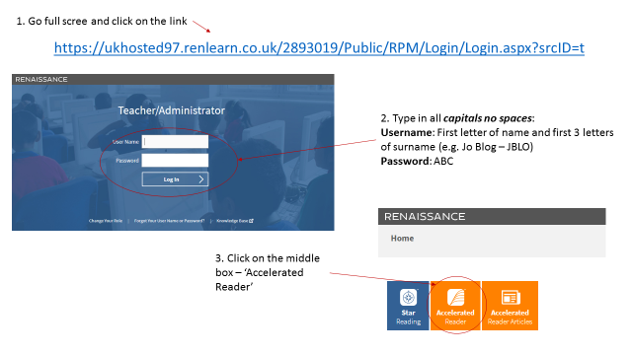
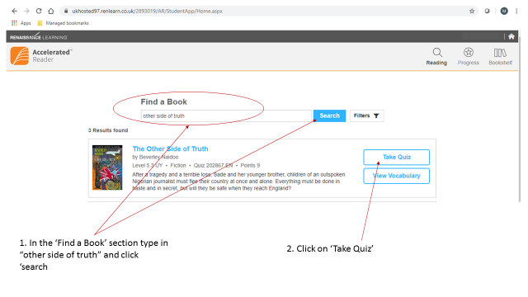
Accessing Accelerated Reader From Home
To access your child’s Accelerated Reader profile, follow the guidance below. Please pay extra attention to the URL, as it is specific to the academy.

Your child’s log in will be the first letter of their forename, and the first four letters of their surname. Their password will be set to default as ABC.

If you need any additional support, please contact e.mccallan@mca.manchester.sch.uk

